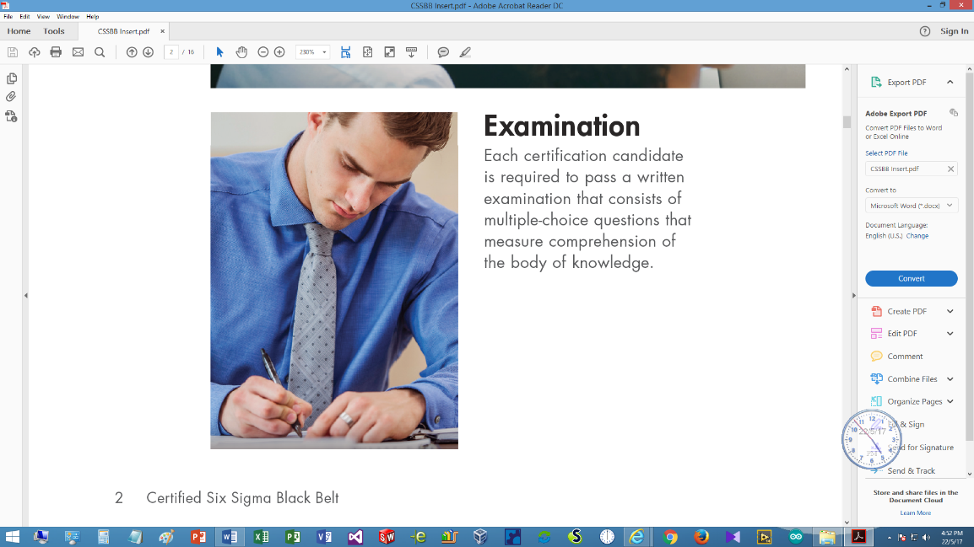HKSQ Workshop

**on**

Body of Knowledge for   
Manager of Quality / Organizational Excellence

31 August – 5 October 2019

(Deadline for registration: 28 August 2019)

# **Registration Form**

|  |  |  |  |
| --- | --- | --- | --- |
|  |  | (in Chinese) |  |

*\* Delete whichever is inappropriate*

Correspondence Address:

|  |
| --- |
|  |

|  |  |  |  |  |
| --- | --- | --- | --- | --- |
|  |  |  |  |  |
| (Private E-mail) |  | (Telephone) |  | (Fax) |

|  |  |
| --- | --- |
| Company Name: |  |
| Position: |  |
| Department: |  |

Company Address:

|  |
| --- |
|  |

|  |  |  |  |  |
| --- | --- | --- | --- | --- |
|  |  |  |  |  |
| (Office E-mail) |  | (Telephone) |  | (Fax) |

Please ⌧ whatever appropriate

Self-financed  Company Sponsored

|  |  |
| --- | --- |
| HKSQ member  ASQ member  Membership No: |  |

TQM Client  Others

|  |  |  |
| --- | --- | --- |
| A cheque payable to “The Hong Kong Society for Quality Ltd.” for the amount of | | |
| HK$ |  | is enclosed. (The registration fee per participant is HK$ 4,100 for members |
| of HKSQ / ASQ, or clients of TQM Consultants Co., Ltd., HK$ 4,400 for others.) | | |

|  |  |  |  |  |
| --- | --- | --- | --- | --- |
| Signature: |  |  | Date: | (dd/mm/yyyy) |

Please send completed registration form with payment to: Dr. Albert Tsang, Hong Kong Society for Quality, P.O. Box 84375, Hunghom Bay Post Office, Hung Hom, Kowloon, Hong Kong.

For enquiries, contact Dr. Albert Tsang at 9182 7810 by phone, or send email to [dr.albert.tsang@gmail.com](mailto:dr.albert.tsang@gmail.com) or [info@hksq.org](mailto:info@hksq.org)